**SUPPLEMENTARY MATERIAL**

**Supplementary Table S1.** Introduced species and current population size and density of mammals [adapted from (Bovendorp and Galetti, 2007)] on the Anchieta island and their respective biomass [body mass according to Gonçalves et al. (2018)].

|  |  |  |  |  |  |  |
| --- | --- | --- | --- | --- | --- | --- |
| Order | Species | Body | No of animals | Mean Densities | Mean Biomass | Population size |
|  |  | mass (kg) | introduced | (Min–Max) (ind/km2) | (Min-Max) (kg) | (Min–Max) |
| Marsupialia | *Didelphis aurita* | 1,04 | Present on the island | 68.80 (41.65–113.62) | 71.62 (44.35–117.52) | 450,15 (272–743) |
| Xenarthra | *Dasypus novemcinctus* | 3,54 | 1 (possibly present) | 45.23 (29.44–69.49) | 160.11 (104.21–245.99) | 295,93 (192–454) |
| Xenarthra | *Tamandua tetradactyla* | 4,56 | 1 | 0.36 (0.12–0.60) | 1.64 (0.54–2.73) | 3 |
| Carnivora | *Nasua nasua* | 3,88 | 13 | 25.06 (14.72–42.67) | 97.23 (57.11–165.55) | 163,96 (96–279) |
| Primates | *Callithrix penicillata* | 0,25 | 5 | 110.29 (83.34–145.94) | 28.56 (21.58–37.78) | 721,62 (545–954) |
| Primates | *Sapajus nigritus* | 3,44 | 33 | 4.2 (3.43–5.26) | 14.46 (11.81–18.09) | 27,48 (22–34) |
| Rodentia | *Dasyprocta azarae and leporina* | 2,16 | 8 | 197.53 (156.81–243.82) | 428.00 (339.8–528.35) | 1292,43 (1026–1595) |
| Rodentia | *Hydrochaeris hydrochaeris* | 31,5 | 7 | 35.30 (19.56–63.75) | 1112.00 (616.14–2008.00) | 272,51 (151–492) |
| Xenarthra | *Bradypus variegatus* | 3,9 | 1 | Extinct | Extinct | Extinct |
| Xenarthra | *Cabassous tatouay* | 5,35 | 2 | Extinct | Extinct | Extinct |
| Xenarthra | *Euphactus sexcintus* | 5,4 | 2 | Extinct | Extinct | Extinct |
| Rodentia | *Agouti paca* | 8,35 | 6 | Extinct | Extinct | Extinct |
| Rodentia | *Coendou spinosus* | 1,3 | 7 | Extinct | Extinct | Extinct |
| Rodentia | *Myocastor coypus* | 4,2 | 11 | Extinct | Extinct | Extinct |
| Artiodactyla | *Mazama gouazoubira* | 16 | 3 | Extinct | Extinct | Extinct |

**Supplementary Table S2.** Bat species recorded on the Anchieta Island, southeastern Brazil.

|  |  |  |
| --- | --- | --- |
| **Bat species** | **Capture Number** | **% of capture** |
| *Artibeus obscurus* | 41 | 21 |
| *Tonatia bidens* | 34 | 17.5 |
| *Artibeus lituratus* | 29 | 15 |
| *Artibeus fimbriatus* | 21 | 10.8 |
| *Desmodus rotundus* | 16 | 8.2 |
| *Sturnira lilium* | 14 | 7.2 |
| *Carollia perspicillata* | 11 | 5.6 |
| *Myotis nigricans* | 8 | 4.1 |
| *Glossophaga soricina* | 7 | 3.5 |
| *Chiroderma doriae* | 5 | 2.5 |
| *Anoura caudifer* | 4 | 2 |
| *Micronycteris_megalotis* | 4 | 2 |
| *Platyrrhrinus lineatus* | 1 | 0.5 |

**Supplementary Table S3.** δ13C and δ15N values of common vampire bats (*D. rotundus*) and potential prey (*H. hydrochaeris* and *N. nasua)* on Anchieta Island, southeastern Brazil, including the number of samples analyzed (N).

|  |  |  |  |  |
| --- | --- | --- | --- | --- |
| **N** | **Species** | **Data** | **δ13C (‰)** | **δ15N (‰)** |
| V1 | *D. rotundus* | 24-Oct-2017 | -14,2954 | 8,2254 |
| V2 | *D. rotundus* | 25-Oct-2017 | -15,2594 | 8,6114 |
| V3 | *D. rotundus* | 25-Oct-2017 | -14,3954 | 7,6084 |
| V4 | *D. rotundus* | 25-Oct-2017 | -15,3524 | 8,2254 |
| V5 | *D. rotundus* | 26-Oct-2017 | -14,2945 | 8,2245 |
| V6 | *D. rotundus* | 27-Nov-2018 | -15,2549 | 8,6141 |
| V7 | *D. rotundus* | 27-Nov-2018 | -14,3944 | 7,6048 |
| V8 | *D. rotundus* | 27-Nov-2018 | -15,3542 | 8,2245 |
| V9 | *D. rotundus* | 28-Nov-2018 | -14,2911 | 8,2298 |
| V10 | *D. rotundus* | 28-Nov-2018 | -15,2530 | 8,6103 |
| V11 | *D. rotundus* | 28-Nov-2018 | -14,3944 | 7,6048 |
| V12 | *D. rotundus* | 28-Nov-2018 | -15,3588 | 8,2283 |
| V13 | *D. rotundus* | 29-Nov-2018 | -14,2910 | 8,2267 |
| V14 | *D. rotundus* | 29-Nov-2018 | -15,2529 | 8,6145 |
| V15 | *D. rotundus* | 29-Nov-2018 | -14,3938 | 7,6078 |
| V16 | *D. rotundus* | 29-Nov-2018 | -15,3547 | 8,2266 |
| Ca1 | *H. hydrochaeris* | 2-Oct-2012 | -16,7847 | 3,4913 |
| Ca2 | *H. hydrochaeris* | 24-Oct-2017 | -17,3644 | 3,6204 |
| Ca3 | *H. hydrochaeris* | 24-Oct-2017 | -14,8884 | 3,9374 |
| Ca4 | *H. hydrochaeris* | 25-Oct-2017 | -15,7004 | 3,3734 |
| Ca5 | *H. hydrochaeris* | 25-Oct-2017 | -28,1092 | 0,8123 |
| Ca6 | *H. hydrochaeris* | 25-Oct-2017 | -22,6754 | 1,8933 |
| Ca7 | *H. hydrochaeris* | 25-Oct-2017 | -21,6574 | 0,1385 |
| Ca8 | *H. hydrochaeris* | 26-Oct-2017 | -21,2901 | 1,1845 |
| Ca9 | *H. hydrochaeris* | 27-Oct-2017 | -20,9002 | 0,8380 |
| Ca10 | *H. hydrochaeris* | 27-Nov-2018 | -20,8765 | 0,7231 |
| Ca11 | *H. hydrochaeris* | 27-Nov-2018 | -19,0987 | 0,6987 |
| Ca12 | *H. hydrochaeris* | 27-Nov-2018 | -21,4398 | 0,9234 |
| Ca13 | *H. hydrochaeris* | 28-Nov-2018 | -19,0123 | 0,8321 |
| Ca14 | *H. hydrochaeris* | 28-Nov-2018 | -18,9378 | 0,8123 |
| Ca15 | *H. hydrochaeris* | 28-Nov-2018 | -18,5619 | 0,7231 |
| Ca16 | *H. hydrochaeris* | 28-Nov-2018 | -17,8472 | 1,1845 |
| Ca17 | *H. hydrochaeris* | 29-Nov-2018 | -17,0120 | 1,8933 |
| Co1 | *N. nasua* | 27-Nov-2018 | -22,4547 | 5,9504 |
| Co2 | *N. nasua* | 27-Nov-2018 | -22,4824 | 6,1823 |
| Co3 | *N. nasua* | 24-Oct-2017 | -23,7364 | 5,9504 |
| Co4 | *N. nasua* | 25-Oct-2017 | -22,4824 | 6,4914 |
| Co5 | *N. nasua* | 2-Oct-2012 | -22,5427 | 6,4003 |
|  |  |  |  |  |
| **N** | **Species** | **Data** | **δ13C (‰)** | **δ15N (‰)** |
| Co6 | *N. nasua* | 2-Oct-2012 | -22,4547 | 6,5133 |
| Co7 | *N. nasua* | 2-Oct-2012 | -22,2527 | 6,8083 |
| Co8 | *N. nasua* | 2-Oct-2012 | -23,0607 | 6,1823 |
| Co9 | *N. nasua* | 2-Oct-2012 | -23,3137 | 6,5553 |
| Co10 | *N. nasua* | 3-Oct-2012 | -23,5317 | 6,2413 |

**Supplementary Table S4. (S5).** Number of events of common vampire bats(*Desmodus* *rotundus*)feeding on capybaras (*Hydrochoerus hydrochaeris*) on Anchieta Island, southeastern Brazil.

|  |  |  |  |
| --- | --- | --- | --- |
| **Date** | **Local** | **Effort** | **Number of Sighting** |
| 24-Oct-17 | Presídio | 5 | 3 |
| 26-Oct-17 | Presídio | 5 | 2 |
| 26-Oct-17 | Presídio | 5 | 3 |
| 1-Feb-18 | Presídio | 1 | 0 |
| 2-Feb-18 | Praia do sapatero | 1 | 0 |
| 3-Feb-18 | Presídio | 4 | 0 |
| 4-Feb-18 | Presídio | 1 | 1 |
| 5-Feb-18 | Escolinha | 2 | 0 |
| 11-Feb-18 | Escolinha | 2 | 0 |
| 13-Feb-18 | Presídio | 3 | 1 |
| 8-Feb-18 | Presídio | 2 | 0 |
| 18-Feb-18 | Presídio | 2 | 1 |
| 24-Feb-18 | Praia do sapatero | 2 | 0 |
| 28-Feb-18 | Presídio | 2 | 0 |
| 1-Mar-18 | Escolinha | 2 | 2 |
| 5-Mar-18 | Presídio | 4 | 2 |
| 27-Nov-18 | Praia do sapatero | 4 | 2 |
| **Total** |  | **47** | **17** |

**Supplementary Table S5.** Number of individuals of common vampire bats *Desmodus rotundus* captured on Island and Mainland areas nearby Anchieta Island, southeastern Brazil, including capture effort, the size of the study area, and if domestic or introduced animals were present.

|  |  |  |  |  |  |  |  |  |  |
| --- | --- | --- | --- | --- | --- | --- | --- | --- | --- |
| Municipality | Study location | Latitude | Longitude | Effort | Individuals | Area | Domestic | Introduced | References |
| (m2h) | mist-neted | (ha) | Animals | Animals |
| Island |  |  |  |  |  |  |  |  |  |
| Ubatuba | Anchieta | -23.54 | -45.05 | 12607 | 16 | 828 | no | yes | 1 |
| Cananeia | Cardoso | -25.08 | -47.92 | 9789 | 3 | 13,500 | yes | no | 3 |
| Angra dos Reis | Grande | -23.14 | -44.18 | 96397 | 46 | 12,072 | yes | no | 4 |
| Mangaratiba | Marambaia | -23.06 | -43.96 | 23560 | 26 | 4,200 | yes | no | 5 |
| São Sebastião | Ilhabela | -23.58 | -46.22 | 9789 | 3 | 13,500 | yes | no | 3 |
|  |  |  |  |  |  |  |  |  |  |
| Mainland |  |  |  |  |  |  |  |  |  |
| Angra dos Reis | Mambucaba | -23.01 | -44.54 | 52 | 0 | 2,072 | yes | no | 4 |
| Ubatuba | Picinguaba | -23.35 | -44.86 | 11097 | 0 | 47,500 | no | no | 2 |
| São Luis Paraitinga | Santa Virgínia | -23.24 | -45.03 | 900 | 0 | 17,000 | no | no | 3 |

1- present study, 2- Colas-Rosa 2009, 3-Muylaert et al. 2017, 4- Gomes and Esberard at al. 2017, 5-Lourenço et al. 2010

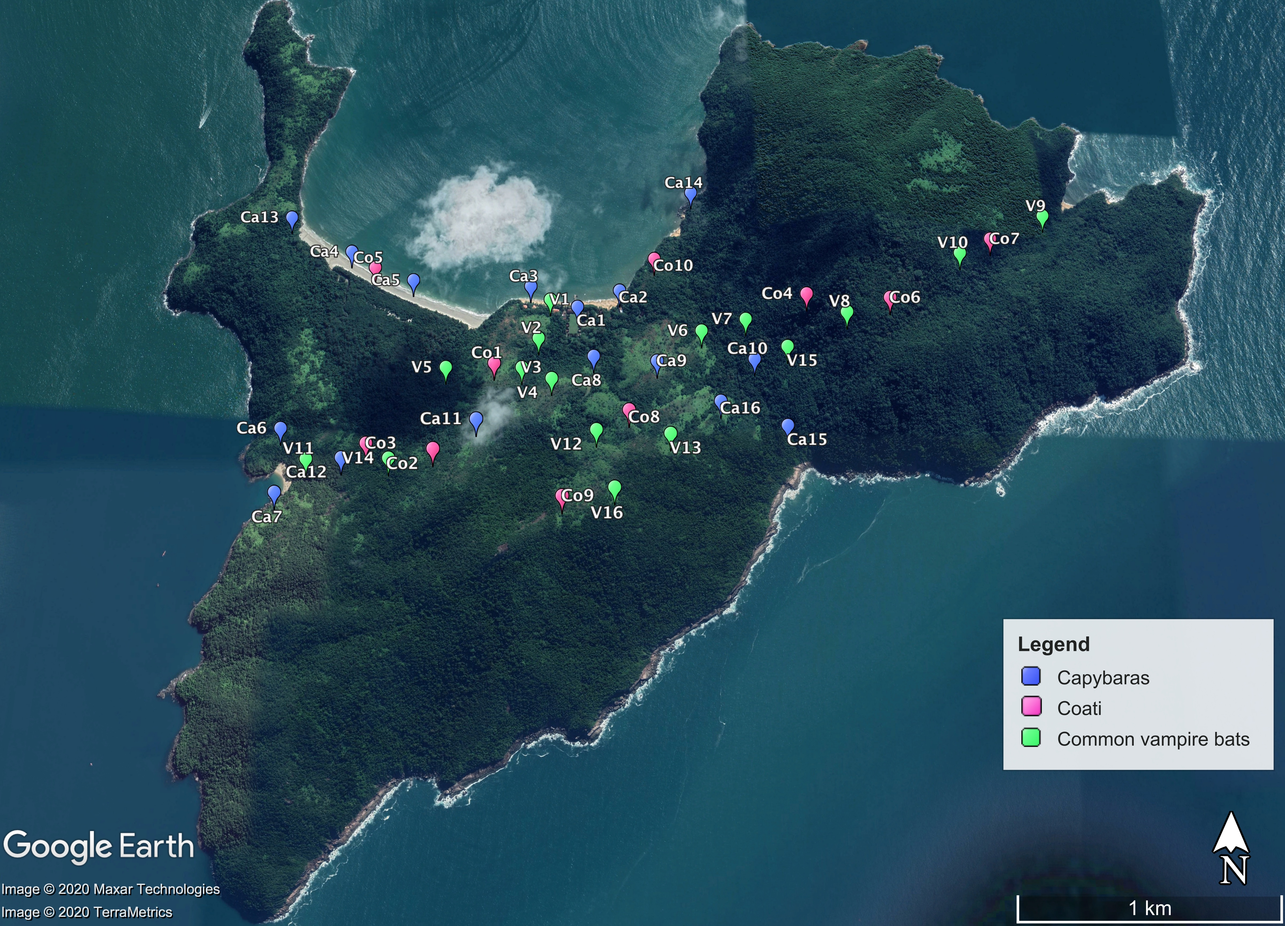

**Supplementary Fig. S1.** Capture and sampling of common vampire bats (*D. rotundus*) and potential prey (1) capybaras (*H. hydrochaeris*) and (2) coati (*N. nasua)* on Anchieta Island, southeastern Brazil.

**References**

Colas-Rosas, P. F. 2009. Estresse nos morcegos Artibeus obscurus e Artibeus fimbriatus (Chiroptera, Phyllostomidae) como resposta à perturbação ambiental. Master thesis. Universidade Estadual Paulista.

Gomes, L. A. C., and Esbérard, C. E. L. 2017. Long-term bat study on an island in the southeastern Brazilian coast with comparison of richness and composition of species among sites. Studies on Neotropical Fauna and Environment *52*(1), 43–52.

Lourenço, E. C., Costa, L. M., Silva, R. M., and Esbérard, C. E. L. 2010. Bat diversity of Ilha da Marambaia, Southern Rio de Janeiro State, Brazil (Chiroptera, Mammalia). Brazilian Journal of Biology 70, 511–519.

Muylaert, et al. 2017. ATLANTIC BATS: a data set of bat communities from the Atlantic Forests of South America. Ecology *98*(12), 3227.